Thurrock Disability Partnership Board
Thursday 18th April 2019- 5.30pm Arrival for 6pm -8pm meeting - The Beehive
Agenda
Item | Timings | Pictures | Item | Led by
 | 5:30–6:00pm |  | Arrival & Networking | --
1. | 6:00-6:05pm  5 minutes | 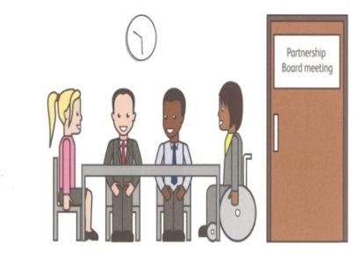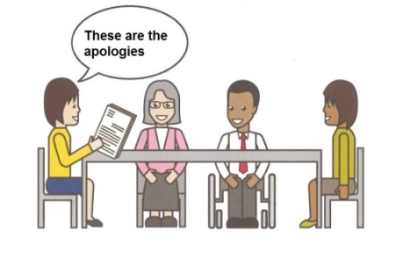 | Welcome and introductions  Apologies – People who can’t come to the meeting | Anne White  Steph Vallis
2. | 6.05-6.10pm  5 minutes |  | Rules of the meeting | Anne White
3. | 6.10–6.20 pm  10 minutes |  | Minutes and updates from the previous meeting of the Disability Partnership Board:  3.1. Any amendments?  3.2. Matters Arising | All
4. | 6.20–6.40 pm  20 minutes  6.40-7.00pm  20 minutes | Health Matters  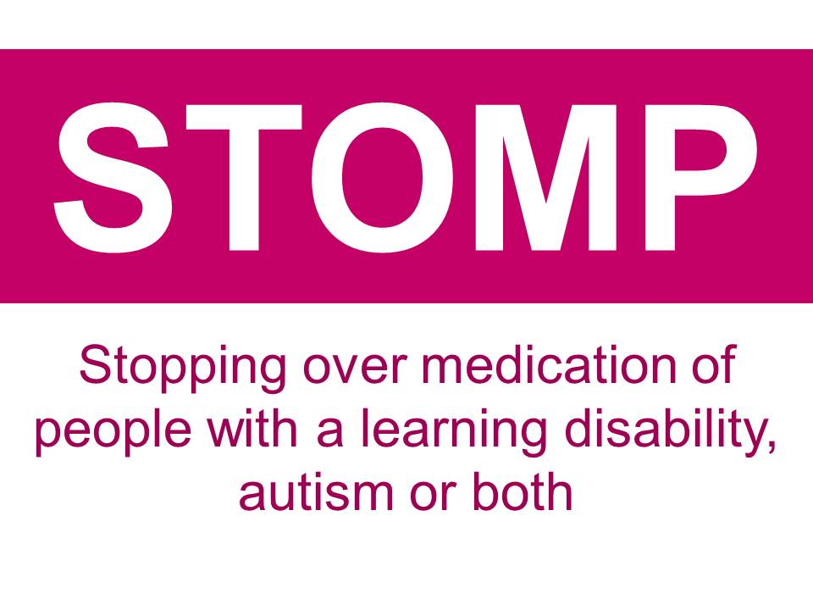  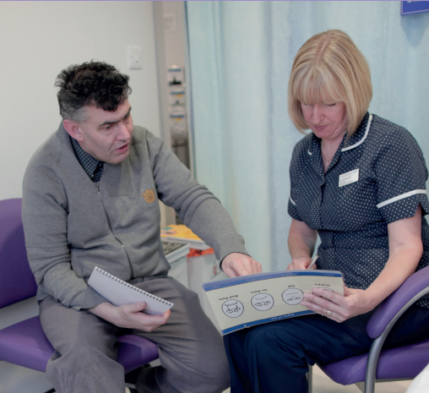 | Stop The Over Medication of People with Learning Disability, Autism or both (STOMP) Initiative  (for information)  Annual Health Check numbers – CCG & TLS Update and  LEDER Update? (for information) | Joanne Eaton / Jean Kendall  Neil Woodbridge / All
5. | 7.00-7:10 pm  10 minutes |  | Refreshment Break | All
6. | 7.10-7.50 pm  40 minutes |  | Consultation on How the Partnership Boards, groups and forums are working for people in Thurrock – Results, Discussion & Next Steps | Ian Evans / All
7. | 7.50-8.00 pm  10 minutes |  | Any Other Business | All
8. | 8:00pm - Finish | 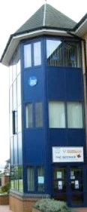 | Date and Time of next meeting:  Thursday 20th June 2019  Arrive from 5.30pm for 6pm – 8pm  The Beehive, West Street | All

