Direct Payments – Quick Guide
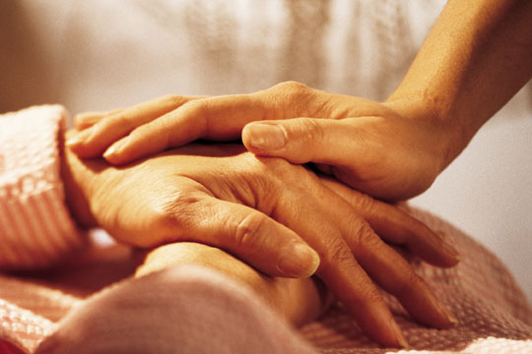

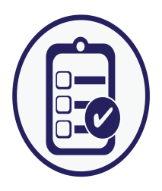
What is A Direct Payment?
A Direct Payment (DP) is money the Local Authority (LA) gives you so you can arrange the support you need.

Will it affect my money?
DPs are not benefits and will not interfere with any benefits you may receive.

Can I get DPs?
You can get a DP if you are over 16 and eligible for support from social care. In order to find out if you are eligible you need to have a care assessment.

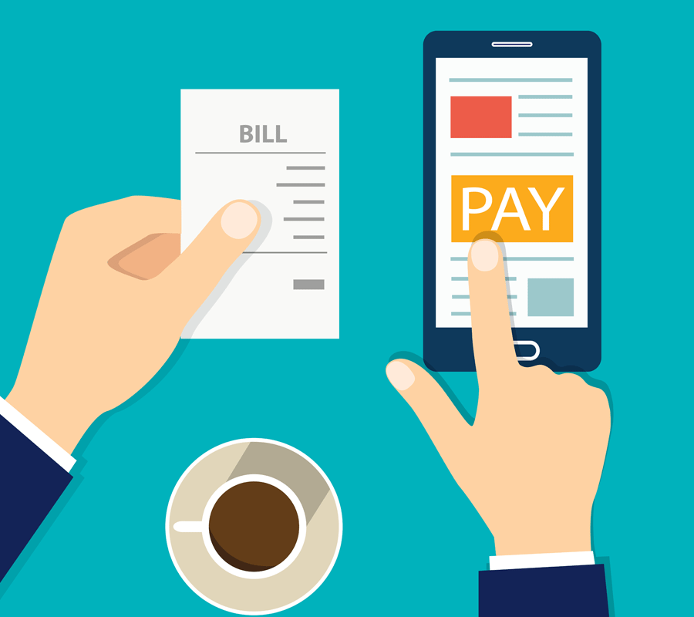
What does using a DP involve?
It will involve dealing with money and arranging your own support.

Can I get help?
Friends and family can help you or you can use Thurrock’s DP and payroll service (run by Purple Zest) that your Care Practitioner can refer you to.
How can I use my DP?
You can use your DP to buy services that are legal and meet your outcomes. These are outcomes are identified in your care assessment.

Finding out more………………………………………

https://www.thurrock.gov.uk/paying-for-your-care-needs/direct-payments

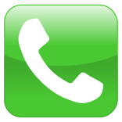
Tel: 01375 652679

