**Thurrock Direct Payments Engagement Group**

**25th January 2018**

**Topic: What’s Out There**

**Attendees:**

Jill Bacon, Patrick Long, Sue Cooper, Heidi Cooper, Lorene Copeland, Roberta Covino, Fausto Covino

**Facilitators:** Ian Evans (Thurrock Coalition), Ian Kennard (Thurrock Council).

**Present:** Sue Wellard (Thurrock Council)

**Welcome and Introductions**

Ian K. Welcomed everyone to the meeting

**Minutes of the previous meeting**

These were agreed as an accurate record. There followed a discussion on numbers and attendance. Ian K. explained that all individuals in receipt of DP have been contacted by mailshot and invited to attend.

**DP Policy - Coproduction**

Discussion around the intention for the DP Group to be involved in co-producing the DP Policy from scratch.

Ian E. stated that it should be possible to set up a discussion board/survey for comments/questions on the DP Policy.

Note: some elements are legal requirements and therefore cannot be changed.

Ian K. also able to attend home visits or undertake/book one-to-one sessions for people who wish to contribute but for whom attending the DP meetings at the Beehive is too difficult, or perhaps at an inconvenient time.

**Theme of the Meeting: DP: What’s Out There?**

“Direct Payments provide choice and control but without the choice what’s the point?”

The Council do ‘contract’ with Care Providers that operate within Thurrock, but this does not cover every business.

These are generally companies that are CQC registered and can get through the financial hurdles of procurement. Even then there are only so many we contract with.

|  |
| --- |
| **Question:** What choice was presented by / to you at the assessment?  **Feedback:** Very generic, not offered much or details at all.  Care options were not addressed at all and no solutions were really offered.  The assessment conversation did not always reflect the outcomes listed on the care assessment when it came through which left people feeling ignored.  The individuals present felt like a summary sheet defining the outcomes would be of use as it takes months to receive the care assessment. |

**Community Resources:** <http://www.strongertogether.org.uk/StrongerTogether/asset_map-18319.aspx>

**Other Business:** <http://www.cqc.org.uk>

**Micro Enterprises**

|  |
| --- |
| **Question:** Are you familiar with these resources, if so how did you find out about them?  **Feedback:** Not familiar with these resources, not heard of Stronger Together.  No these types of resources are not known or pointed out as reference material for the individuals.  Micro enterprises were mentioned in a case but this was not the norm. |

**Micro Enterprises**

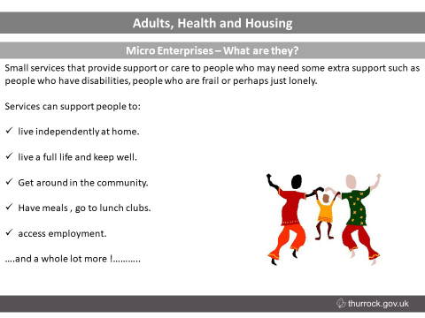 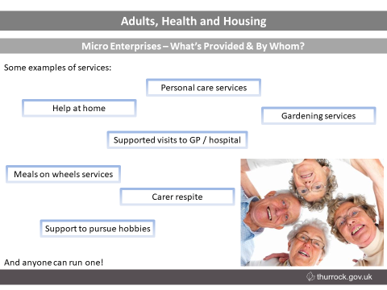

Micro Enterprises build on and connect to the work already carried out in the community – hubs, forums, LACs, Time bank/Ngage (volunteers).

* Delivered by local people to other local people.
* More personalised support than larger providers, particularly in home-based care.
* People using micros are more likely to get help to do the things they value and enjoy, compared with people using larger services.
* They can be more flexible than larger providers in the way care in the home is delivered (e.g. staying to have a meal with someone rather than simply preparing food and leaving).
* They can offer better value for money than larger providers – and provide employment for local people.
* **Micro Enterprises – Questions of further information:**
* Sue Wellard: | Community Micro-Enterprise Co-Ordinator |
* Email: swellard@thurrock.gov.uk
* Tel: 07867696302

**Coffee Break**

**Direct Payments Engagement Group – 25/1/18**

**Case Study Q&A – How Can I Find Out What’s There?**

**Scenario 1**

James is a 19-year-old man who has just finished a history course at in a mainstream college which he accessed via a Motability car his parents use on his behalf. He is profoundly deaf and has difficulty weight bearing due to his poor physical health. As a result of his conditions and his college course coming to an end he has found himself increasing socially isolated and has been assessed as having a personal budget (which he is taking as a Direct Payment) of £148 per week to assist with this. James is able to manage his Direct Payment independently as he has very strong mathematical skills and likes the idea of tracking what he spends on a spreadsheet.

**Scenario 2**

Jane is a 56-year-old woman who has a learning disability who has just moved to Thurrock with her mother who is her main carer. Jane is passionate about art and music and previously attended a variety of community clubs and programmes that enabled her to socialise with people with similar interests, but now is unsure what is available to her in Thurrock. Both Jane and her mother are not computer literate and do not own a computer and in addition to this Jane is not able to read or write. Her personal budget of £240 per week is paid to a Direct Payment support agency as Jane’s mother finds the thought of managing the returns too much.

**Questions and Feedback - Group Activity**

|  |
| --- |
| 1. **What would be the best way for James and Jane to access information on services in Thurrock?**   **James:**   * **Text phone** * **Web** * **Adviser from the college** * **A useful information sheet in the introductory pack** * **In British Sign Language or the most appropriate method for him** * **From a Local Area Co-ordinator (alongside a BSL interpreter)**   **Jane:**   * **A signed and subtitled video/dvd** * **P.A./ Carer – out and about, doing the research** * **Carer’s Assessment** |

|  |
| --- |
| 1. **What would you think James and Jane would need to know to make a decision to purchase or use these services?**  * Direct Payments Policy * Outcomes * What they can/can’t use DP for. * Understandable format/accessible format * Preferred provider list * Rates of pay – including enough funding to cover the detailed breakdown of: National Insurance, Statutory Sick Pay and Pension contributions |

Dates of future meetings:

* **Direct Payment Financial Pressures: 20th of February 2018 from:   
  1:00 pm to 3:00pm at the Beehive Resource Centre, West Street, Grays, Essex RM17 6XP.**
* **What Type Of Support Do You Require?: 27th of February 2018 from: 1:00 pm to 3:00pm at the Beehive Resource Centre, West Street, Grays, Essex RM17 6XP.**