Thurrock Disability Partnership Board
Thursday 13th December 2018- 5.30pm Arrival for 6pm -8pm meeting - The Beehive
Agenda
Item | Timings | Pictures | Item | Led by
 | 5:30–6:00pm |  | Arrival & Networking | --
1. | 6:00-6:05pm  5 minutes | 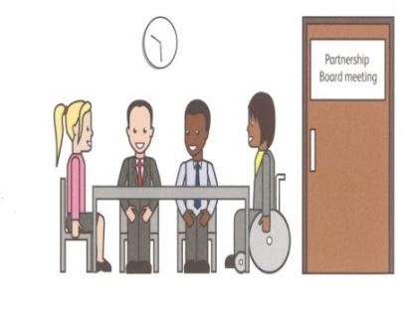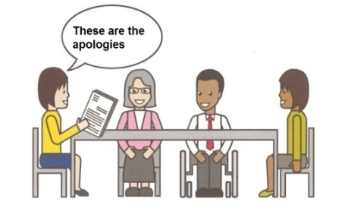 | Welcome and introductions  Apologies – People who can’t come to the meeting | Anne White  Steph Vallis
2. | 6.05-6.10pm  5 minutes |  | Rules of the meeting | Anne White
3. | 6.10–6.20 pm  10 minutes |  | Minutes of the previous meeting of the Disability Partnership Board:  3.1. Any amendments?  3.2. Matters Arising | All
4. | 6.20–6:45 pm  25 minutes | 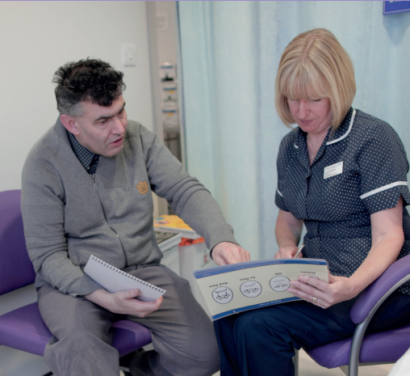 | Learning Disability Health checks - Progress in Thurrock | Mayowa Kushimo, Neil Woodbridge, John Paddick
5. | 6:45-7:00pm  15 minutes |  | Mental Health Peer Review Update & Action Plan | Les Billingham / Catherine Wilson
6. | 7.00-7:15 pm  15 minutes |  | Refreshment Break | All
7. | 7.15-7.25 pm  10 minutes |  | Thurrock Diversity Network and the Local Account Priorities | Ian Evans
8. | 7.25-7.50  25 minutes |  | Consultation on How the Partnership Boards, groups and forums are working for people in Thurrock – Information and survey | Ian Evans / All
 | 7.50-8.00 pm  10 minutes |  | Any Other Business | All
9. | 8:00pm - Finish | 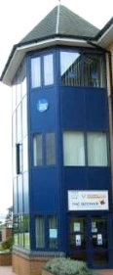 | Date and Time of next meeting:  Tuesday 20th March 2019  Arrive from 5.30pm for 6pm – 8pm  The Beehive, West Street | All

