Thurrock Mental Health Forum for Individuals, Families and Carers
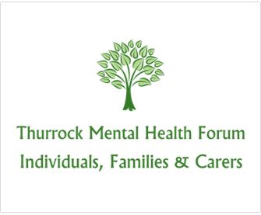

Monday 14th November 2018 2.30pm – 3.30pm
Thurrock Mind Crown House, Crown Road, Grays, RM17 6JD

Attendees:
Ian Evans (chair)
Stephanie Vallis (minutes)
Kenneth Moore (Mind)
Jeanette Lambert (Mind)
David Eyres (Mind)
Danielle Kay (Mind)
Jacqui Lissenden (Thurrock Carers Service)
Harpal Kang (Mind)

Apologies:
Leanne Horwill

- Welcome and Introductions
Ian welcomed everyone to the meeting.

- Minutes and Matters Arising from the Previous Forum Meeting
The minutes were read and agreed as a correct record.
Ian went through the Mental Health Peer Review (See attached action plan) which was held in June 2018 and the findings which were summarised for consideration, which were as follows:
- Commissioners to develop an improvement plan for EPUT as a provider in Thurrock;
- Develop joint commissioning arrangements between the Council and the CCG;
- Commission for the “middle” of mental health needs;
- Create a Mental Health Programme Group, including children and transition, to ensure the elements of an improvement plan are coordinated to overcome current fragmentation of initiatives, including the JSNA recommendations;
- Develop service user involvement further e.g. in training, remunerated participation in project groups, reviews and inspections;
- Thurrock Council and CCG to agree new operating model which develops referral routes and new pathways whilst managing demand in the system;
- Drive innovation for Thurrock Mental Health, which matches Adult Social Care Transformation;
- Capitalise on the “place at the table” to push models of integration in the next 10 years;
- The current model of social work needs urgent revision; social workers need support to practice with support in crisis incidents and bed finding.

Danielle asked if any actions have come from the areas for consideration. See section 3.5 of the review.
Ken asked if the Council will change anything from the recommendations and Ian explained the working together person centred approach. As a forum we can monitor what is happening, Ian can take questions or concerns to the Mental Health Partnership Board which is chaired by Roger Harris Corporate Director – Adults, Housing and Health.
Jacqui expressed that she thinks there is not enough support for people battling alcohol and mental health
There is a service called Inclusion Visions Thurrock. Our Visions Thurrock service offers a free and confidential service to residents of Thurrock aged 18 and over affected by drug or alcohol use. At Inclusion, we believe service users are capable of changing their lives and our role is to facilitate that change through motivation and providing interventions that work. We offer a free and easy to access service. If you are concerned and looking for some advice or support, then please call: 0300 303 1018. To find out more about what is available please visit: https://www.inclusion.org/

The group spoke about Integrated Medical Centres and Ian explained how they will work.
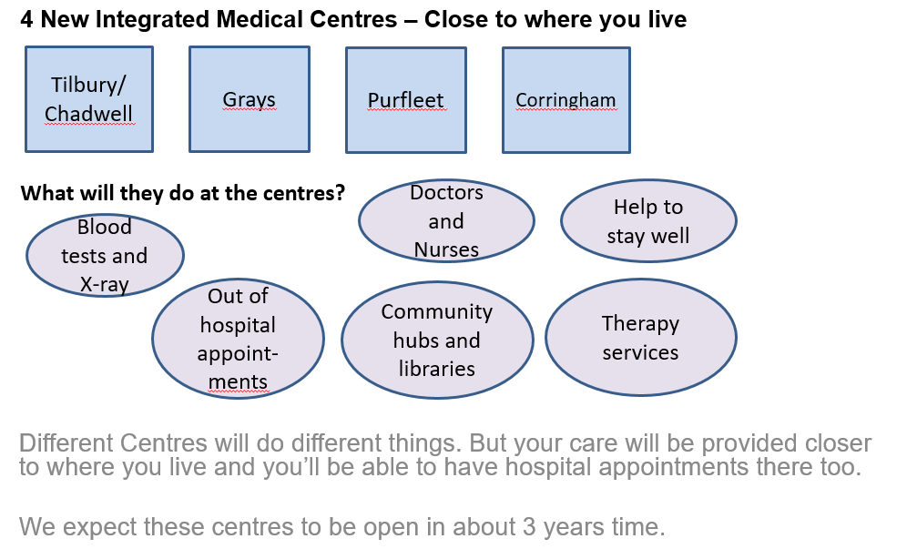

Jeanette asked where they will be based. ACTION Ian Evans will find out locations.

- Presentation and Group Discussion on the Partnership Boards, Groups and Forums in Thurrock – Ian Evans
Please see Ian’s presentation attached
Thurrock Coalition wants hear about peoples’ experiences and views on how they currently find out about what's happening with Health and Social Care in Thurrock and how they would take part and make their voice heard.
We hope that by sharing experiences and views we can influence the improvement of services in the future.
The answers will help us to identify issues and to help increase the numbers and range of people taking part and feeling able to speak up about important local topics in consultations and events by visiting new and existing groups.

- Survey on the Partnership Boards, groups and Forums in Thurrock.
Surveys were handed out to the group and filled in.
The group all agreed that outreach work could be more beneficial as they would feel more comfortable to speak at the groups that they already attend.

- Refreshments

- AOB

David asked for a progress update on the Mind, Bridge Road renovation, as members from the group feel that is a more welcoming and numbers of the group are dropping since being based at Crown House.
ACTION Ian Evans to find out who the trustees are and try and find out a timescale for the renovations at Bridge Road.

Date of Next Meeting – March 2019 To be Confirmed.

