Thurrock Disability Partnership Board
Thursday 21st June 2018- 5.30pm Arrival for 6pm -8pm meeting
The Beehive
Agenda
Item | Timings | Pictures | Item | Led by
 | 5:30–6:00pm |  | Arrival & Networking | --
1. | 6:00-6:05pm  5 minutes | 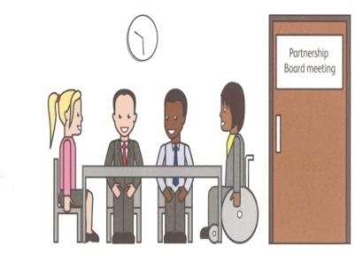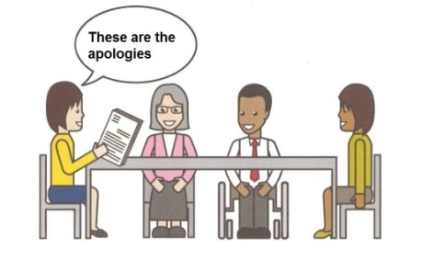 | Welcome and introductions  Apologies – People who can’t come to the meeting | Anne White  Karen Haltham
2. | 6.05-6.10pm  5 minutes |  | Rules of the meeting | Anne White
3. | 6.10–6.20 pm  10 minutes |  | Minutes of the previous meeting of the Disability Partnership Board:  3.1. Any amendments?  3.2. Matters Arising | All
4. | 6.20–6:45 pm  25 minutes |  | Video introduction and Discussion on LeDeR – Actions for Thurrock | All
5. | 6:45-7:10pm  25 minutes |  | Safeguarding Case Studies  Mental Capacity & DoLS | Liana Kotze / Graham Carey/ Lynne Morgan
6. | 7.10-7:20 pm  10 minutes |  | Refreshment Break | All
7. | 7.20-7.25 pm  5 minutes |  | Board Members Updates including:  Thurrock Coalition | Ian Evans/Karen Haltham
8. | 7.25-8.00  35 minutes |  | Thurrock Council -  Strength based approaches, the Place based forward plan and  Any Other Business | Les Billingham
9. | 8:00pm - Finish | 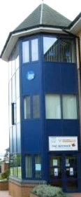 | Date and Time of next meeting:  Thursday 20th September 2018  Arrive from 5.30pm for 6pm – 8pm  The Beehive, West Street | All

