Adult Social Care

Direct Payments Policy and Guidelines

This Policy should be read in conjunction with the Council’s Personal Budget Policy and Assessment and Eligibility Policy. The Policy has been refreshed to ensure compliance with the Care Act (the Act) 2014.

The Policy sets out the processes by which Thurrock Council’s Adult Social Care Directorate (the Service) will meet the duties defined within the Act, and defines the Council’s undertaking to service users and their representatives concerning the service they should expect to receive.

Version History
Version  # | Implemented  By | Revision  Date | Approved  By | Approval  Date | Reason
1 | Ian Kennard |  | AHH DMT | 13/11/18 | To co-produce with users / stakeholders and address pressing operational issues.

Table of Contents

- The Law 3
- Principles 3
- Can I Have A Direct Payment 4
- Who Cannot Have A Direct Payment 6
- Mental Capacity 6
- People Who Lack Capacity To Consent 8
- Where Court of Protection or Lasting Power of Attorney is in Place 8
- Customer Journey (Overview) 9
- What Can / Cannot A Direct Payment Be Used On 11
- Will The Person Have To Pay Towards Their Direct Payment 12
- Employing Relatives 13
- Subsistence Payments 14
- Getting A Direct Payment Started 15
- Requesting Direct Payment Spend Information 17
- Audits for Direct Payments 19
- Underspends 20
- Misuse of Direct Payments 21
- Health Funding 23

Language and Terminology

The below are word, names and terms used in this document and subsequent definitions to help make the Policy more accessible:

‘The Council’ – Thurrock Council.

‘The Person’ – refers to an individual who is eligible for care and support or is undergoing a care assessment.

‘Care Professional’ – will be a Social Worker or Support Planner involved in the assessment or support of a person.

‘Service Manager’ or ‘Strategic Lead’ – refers to senior managers within the Council at varying levels.

‘Finance Officer’ – refers to a member of the Customer Finance Team responsible paying and auditing Direct Payments.

‘Donee’ – Is a person who is given a power of appointment.

‘Surrogate’ – is a substitute, especially a person deputising for another in a specific role.

The Law

This policy has been put together in response to the below pieces of legislation:

The policy will be reviewed each year (or when necessary) to ensure it is still in keeping with any changes to the law.

The Principles

The principles contained in the picture below will inform how the Direct Payment policy will shape the views and approach the Local Authority will take towards providing and monitoring this service.

The principles will be to:

Encourage Creativity – To use any available services or things within or outside the community to meet the person’s outcomes. If the person has an idea on how to meet their outcomes they should be given a chance to express this. If they are unsure if this is okay they should be able to simply ask.

Use On Outcomes In The Assessment – Make sure that Direct Payment money is only used on what outcomes are shown in their (most recent) assessment. If they think something is missing they can ask to be reviewed.

Be Legal – Make sure the person only buys services or things that are legal. Even if they are paying for someone’s time they need check to make sure that things like VAT or other taxes are being paid or else they could get into trouble.

Be Safe – Make sure items bought are safe to use. Make sure anyone the person buys services from is qualified, insured and have the right security checks in place.

Get Value for Money – As the person is given an amount of money from Thurrock Council to meet their outcomes they need to make sure they can meet them all. They need to keep in mind if they want to pay more for one thing they may have less to spend on others and if they can get something cheaper they will have more money left over to use elsewhere.

Can I Have A Direct Payment

To be eligible to have a service they must have at least 2 of the following outcomes for adults with care and support needs:

For carers (16 or over) with support needs they would need at least 2 of the follow outcomes:

If a person who is eligible but lacks capacity to look after or manage a Direct Payment they can get a ‘Suitable Person’ to help. This could be a person with Lasting Power of Attorney; someone appointed by the Court of Protection or a friend or family member who agrees.

Other people that can receive Direct Payments if they:

The Council likes people to have Direct Payments as they give them the most choice and control over their care as they can pick and choose when, where and how it is taken.

BUT - Direct Payments are a choice; they do not have to have them if they don’t want to.

Who Cannot Have A Direct Payment

There are only a few situations where a person cannot have a Direct Payment. These situations focus around a person’s mental health or around where a person has or are in legal actions due to issues with money. These are:

The Council has to think about what the Care Act (2014) states about this as well (sections 31 and 33) in allowing access to Direct Payments. Also if a person owes any other money to the Council (things like Council Tax, rent or care charges) then the person may not be able to have a Direct Payment as this may show the person may not be able to handle money very well.

However - the decision to give a Direct Payment to a person who owes money to the Council will be viewed as an exception and would have to be made by a Service Manager or Strategic Lead.

Mental Capacity

The Council must establish if a service user has capacity to consent to receiving Direct Payments before it can provide them. Obtaining consent might be a process involving continuous discussion.

An easy read guide to this topic can be found via the below link: https://www.local.gov.uk/sites/default/files/documents/easy-read-guide-pdf-16-pa-2cc.pdf

If a service user has capacity to consent to Direct Payments but needs additional support in order to manage them, Direct Payments can be paid to a nominee who can help the person manage them, as long as the person who is eligible to receive the Direct Payments is in agreement.

If a service user lacks capacity to consent (subject to certain conditions) Direct Payments may be made to another person on behalf of the person needing support. This must be an appropriate and willing suitable person.

Details on assessing capacity can be found in the “Thurrock Policy on Mental Capacity”. Capacity is assessed on an individual basis, in relation to the specific decision to be made, and in accordance with the Mental Capacity Act 2005. This stipulates that there is a presumption of capacity, unless it can be established that a person lacks capacity. In order to comply with the requirements of the Act, the Council must take all practicable steps to help the service user make the decision before it can treat them as unable to make the decision. The steps taken to assess capacity will be recorded. Any decision that a person lacks capacity to consent must be shown to be reasonable.

If capacity is borderline the Council may set up a trial period of Direct Payments, during which capacity can continue to be assessed.

A person might have capacity to consent to receiving a Direct Payment for one service, for example one that involves paying a regular small payment, but not one that involves more complexity, such as employing an assistant. The latter involves compliance with the tax and national insurance regimes and employment law. In this situation it may be appropriate that a Trust is developed to enable the service user to employ the assistance.

The Council will review any decisions about a service user’s capacity at appropriate intervals so that it can be sure that all those in receipt of Direct Payments have as much control as possible.

If the Council is satisfied that regained capacity is only temporary it will continue to make Direct Payments to the suitable person. In accordance with the Guidance, the suitable person in these circumstances must allow the beneficiary to manage their own Direct Payments during any time when they have gained or regained capacity to consent and are able to manage payments themselves.

The Council may discuss with the person receiving Direct Payments the possibility of making a Lasting Power of Attorney to manage their affairs relating to personal welfare in the event that they lose capacity to consent to Direct Payments in the future.

People who lack capacity to consent to Direct Payments

Where an adult service user lacks capacity to consent to receipt of a Direct Payments the Council must:

- Undertake a Best Interest Assessment to test if it is the best interest of the person to receive Direct Payments;

- Consult family and friends as part of the best interest decision-making process;

- Be satisfied that the person’s community care needs can be met by the Direct Payments;

- Be satisfied that the recipient of the Direct Payments will act in the best interests of the service user;

- That in all the circumstances, a Direct Payments would be appropriate;

- If the suitable person is not the spouse, civil partner, partner, close relative (or spouse of a close relative) or friend involved in the provision of care of the person lacking capacity, the Council must obtain an enhanced Disclosure & Barring Service Certificate for them.

Where Court of Protection or Lasting Power of Attorney is in place

A surrogate, that is a Deputy appointed by the Court of Protection or a donee of a Lasting Power of Attorney created by them who has been given authority to make “decisions about securing the provision of a community care service” to meet that person’s needs.

A surrogate has the power to refuse to consent to a Direct Payments.

If the deputy or donee does not have the power to make “decisions about securing the provision of a community care service” the Council will ask them first if they wish to be the person’s representative.

Customer Journey (Overview)

The below picture shows the person’s journey through the Adults Social Care system at a very high level:

The steps are as follows:

Eligibility – Does the person qualify for care and support?

If not the person will get information and advice.

If yes the person will receive a full care assessment.

Care Assessment – This will detail the person’s needs and will look at the support they have from friend, family or the community.

Outcomes – These will be the things the person wants to achieve.

Financial Assessment – The Care Professional will ask the person to complete a form for a financial assessment. A Finance Officer will then come out to complete this.

Indicative Budget – This will be the estimate of what it will cost to meet these outcomes.

Support Planning – This will be where the person will choose how to meet their outcome (receive a Direct

Payment for example) and determine what sort of services / businesses / things the money they get can be used on.

Financial Approval – The Care Professional will have their worked checked (usually by their manager) and they will then agree to fund the care or not. If they don’t the Care Professional may want to speak to the person about other ways to meet your outcomes.

Personal Budget – This is the amount of money that it will cost to meet the person’s outcomes after the person’s contribution (that the financial assessment makes clear) taken away.

What Can / Cannot A Direct Payment Be Spent On

The Care Act (2014) tells us that Direct Payments must be spent on goods or services that are:

The Council also states the following things would be an inappropriate use of a Direct Payment unless a Service Manager or Strategic Lead has been given their agreement beforehand:

Example 1:

It is easy to forget all of the rules around Direct Payments but a person can always call their care practitioner to check.

Example 2:

If a person make a mistake they can rectify this themselves (for example pay money back into their Direct Payment account and make a note on their return) or contact the Finance Officer for advise.

Will The Person Have To Pay Towards Their Direct Payment

The person may have to. BUT the Council will have to complete a financial assessment to see if you have to. This assessment looks at your income and the things you pay out for such as rent; mortgage; household expenses; things you pay out for due to any conditions the person may have. A basic overview is shown below:

Not all benefits and income is included in the assessment but the Council does have a policy that details how it charges which is available on request, or the person can speak with a member of the Customer Finance Team.

Employing Relatives

At present Direct Payment regulations prevent people from using Direct Payments to buy services from the following:

However, this only applies if they live in the same household as the person receiving the Direct Payment. But exceptions can be made if it is the best way of meeting the person’s outcomes though this would need to be agreed by a Service Manager or Strategic Lead.

Employing relatives can create additional types of interactions that could place additional stress on a person’s own situation and blur the lines of the existing relationships that need to be considered by both the person and the care practitioner.

Some of the most common types of overlapping relationships are shown below (though it is possible for several of these to overlap at the same time):

The additional pressures of adding an employer / employee dynamic my cause existing relationships to be strained or falter and will need to be considered in the care practitioners contingency plans.

The person has all the same responsibilities and requirements in employing a spouse / partner / relative that they would have employing any other person as a carer. These can be found at the following website: https://www.gov.uk/contract-types-and-employer-responsibilities.

If the spouse / partner / relative being employed by the person is claiming any benefits personally or relating to any current caring role they would need to disclose any paid employment to the appropriate benefit agency.

Subsistence Claims

What this means is any additional money the person’s carer can claim while performing their role in helping meet the person’s outcomes.

These expenses are those that would not be set out within the contract of employment (whereas mileage payments would) and tend to revolve around things such as meals.

The subsistence rates that are applied to Thurrock Council employees are below but can only be claimed if the person is working outside of normal working times or duties:

Claims should be relevant to the person’s outcome i.e. if your outcomes are for the delivery of personal care in the morning and the contract the person has is just for this, it would be extremely unlikely any claims would be necessary.

Any need for subsistence should be discussed at the point of assessment of needs so this can be captured and reflected in contingency plans (if appropriate). Amounts considered for subsistence should be appropriate to where the outcomes will be met (i.e. central London will be more expensive). Alternatively the person and the care practitioner should discuss amounts that could be appropriately used to cover the entire day.

Regardless of the approach the main consideration should be - how and what the person is to pay out for on behalf carer and how will they meet the rest of their outcomes with the money they have left.

Getting A Direct Payment Started

What The Person Has To Do

The person will have to first decide from whom they wish to purchase services to meet their outcomes. They can be loosely broken down as follows:

It is important to remember that in whatever option a person chooses they must always stay within the law, therefore they must always have the correct insurance; pay the correct levels of tax; and national insurance.

All the responsibilities of being an employer can be found at https://www.gov.uk/contract-types-and-employer-responsibilities.

This can be a very complicated and technical area and help and support can be provided by the Council contracted agency or Advocate support that a care professional can direct people to.

The person would then have to decide how they would like the Direct Payment to be managed and this can be done in a number of ways:

The person must also be willing to have a dedicated account (if they choose to self-manage their Direct Payment) in which to receive the payment. This makes providing evidence on how the money is used much easier for both the person and the Council.

The person will also complete the sections of the Direct Payment agreement that apply to them, sign it and return this to the care practitioner. This agreement can be quite technical and if the person requires support then the care practitioner can arrange Advocate support to ensure the person has the correct level of advice and support.

What The Council Has To Do

The steps a Care Professional has to take are outlined as below:

It is important to remember that the Council (at present) delegates its legal responsibility to provide information advice and support as well as payroll and managed account services. Therefore we must ensure the offer of support (or indeed Advocacy) is always made. This is in addition to any support that may be required due to issues with a person’s mental capacity. This would need to be done in a timely manner in order to not hold up the Care Assessment unnecessarily.

The Direct Payment Agreement is the legal basis to enable money to be paid to the person from the Council. Ensuring this is explained clearly and it has the appropriate information, rates and start-up cost is essential. If this is incorrect is may cause the person difficulty in purchasing care / support or even hold up monies being paid to help meet identified eligible needs.

Start-up costs are provided to the person when they wish to employ a Personal Assistant. These are made as a one-off payment when the Direct Payment is first issued and it is expected that the person put aside money from future payments to account for these expenses. The Council currently pays:

- £135.00 for Employer Liability Insurance.

- £44.00 per DBS check required.

- £150.00 advertising costs.

Ensuring the account the individual uses is only used for Direct Payments will aid the person and the Council in the long term as it will be easier to see what the person has to meet their outcomes and easier to evidence when they complete their return. In addition to this checking to ensure the appropriate people have access to this account will help with contingency planning and help reduce any potential for safeguarding concerns.

Requesting Direct Payment Spend Information

  - A person is required to send in details of how they have used their Direct Payment – this is call a return or audit.

  - The Audit is a legal requirement for the Council as we must make sure Public money is used appropriately.

  - The first step of this is for the person to send back the information to the Council at the correct time and these can be different depending on the following.

  - Normally a person will send in their returns as follows:

- If the person has just started a Direct Payment this will be after 4 months.

- If the person has had any issues or is within the first 3 years of having a Direct Payment the information will need to be returned every 6 months.

- If there has been no issues on a person’s returns after 3 years they will only need to be submitted every 12 months.

  - The process showing how the Council does this is shown below:

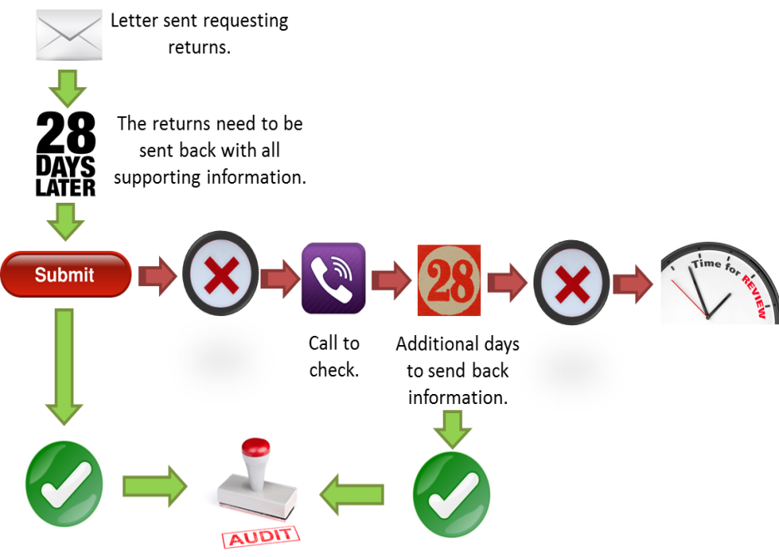

  - The steps for the above are as follows:

    - A letter is sent to the person from the Council asking for the details of how their Direct Payment was spent for a particular period.

    - The person has 28 days to return the information in the freepost envelope provided.

    - If the information is provided to the Finance Officer will undertake the audit (look through the return to see if the spending is in keeping with the person’s outcomes).

    - If the information is not returned within 28 days the person will receive a telephone call from a Finance Officer to enquire why this has not been provided and see if the person requires any help.

    - Another 28 days will be given to the individual to return the information and a letter will be sent by the Finance Officer to state this.

    - If the information is received within 28 days the Finance Officer will audit the return.

    - If the information is not received within 28 days the Finance Officer will request a care review to see if the Direct Payment is still the right way to meet the person’s outcomes.

  - Once the returns have been sent in to the Council these will be reviewed by a Finance Officer. The Officer will check to see if the spend is in keeping with the person’s outcomes.

15. Audits For Direct Payments

  - The audit process is where the Finance Officer check the person’s Direct Payment spend against the outcomes in the care assessment.

  - The process for doing this is shown below:

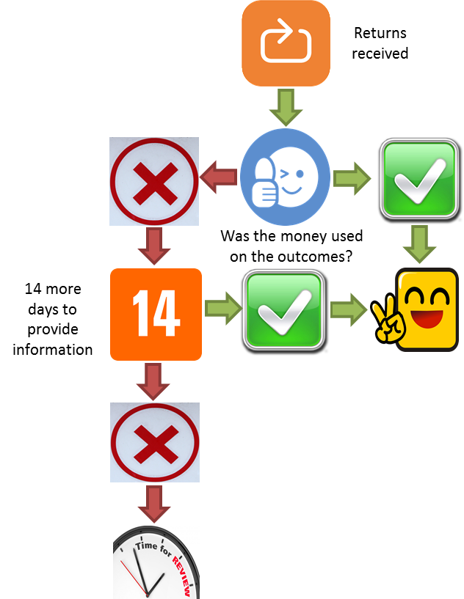

  - The steps for the above are as follows:

    - The Finance Officer goes through the return and compares what the Direct Payments has been spent on to the person’s outcome as stated in their care assessment.

    - If the items / services purchased are legal and appropriate the audit is finished and diarised.

    - If the audit shows that monies were used on items / services that do not appear appropriate the person will be written to asking for clarification. They will be given 14 days in which to respond. If the person is unwell or unable to respond within 14 days this can be extended by the Finance Officer.

    - If the additional information resolves any concerns the audit is completed and diarised.

    - If the additional information does not address the concerns the person will undergo a care review in order to determine if a Direct Payment is still appropriate to meet their outcomes.

Underspends

An underspend is where the person has money left over in their Direct Payment account after they have bought all the necessary support to meet their outcomes in a set period of time.

The Council monitor this as if a person is not using all the allocated money it may suggest that they are not meeting all their outcomes and this could put the individual at risk.

A person’s may keep up to 8 weeks of money in their Direct Payment account. It can be more of this if you let the Council know. The person should think about the following:

Should a person exceed the tolerance level and there is no obvious reason why this level is exceeded, a care review will be scheduled and the money over the 8 weeks tolerance would have to be repaid to the Council. A person will however have the opportunity to discuss any reasoning behind increased levels of money before any refunds will be paid. If there is any disagreement over the returning of any tolerance a Service Manager of Strategic Lead will make the final decision.

If the person has a Direct Payment for respite care in a residential care setting they need to remember that the Care Act states:

It is always good practice for the person to either put in writing any need to exceed the tolerance level to prevent any or ensure this is captured within the Care Assessment or a contingency plan.

Misuse Of Direct Payments

The ‘misuse’ of a Direct Payment is where:

Where one or more of the above has seemed to have taken place a care practitioner will be asked to carry out a review to see if a Direct Payment is still the best way to meet the person’s outcomes.

During this review the care practitioner should take all reasonable steps to remain in contact with the individual throughout the review process and carry out the review as quickly as possible.

Where it is appropriate and / or requested Advocacy or other support should be offered so that the person’s views and best interests are represented.

An overview of the review process is as follows:

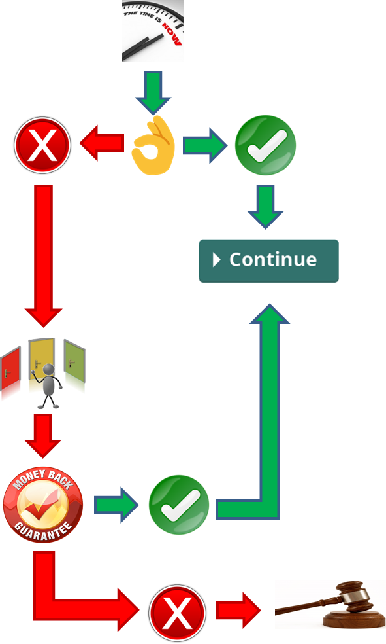

The steps for the above are as follows:

The care review takes place in order to determine if the Direct Payment used appropriately.

If the person requires support throughout this process they can have an Advocate or suitable person present to help represent their interests.

If it has then the Direct Payment remains in place and the relevant Council systems updated with the outcome.

If it is deemed that the Direct Payment has been misused then the Direct Payment will cease and other options discussed about how to meet the person’s outcomes.

Any misused money will be requested back. If the person is happy to do so then the following options are available:

Deductions from future monies received from the Authority, although the individual would be required to meet the shortfall in funds to meet their outcomes from their own monies.

A repayment plan with the Council where the person would have to pay an appropriate sum on a regular basis.

If the person does not agree to refund monies then legal action may be taken to recover the funds. This may result in the person paying Court fees and interest as well if the Court finds against them.

If the person does not agree with the outcome they may object via the Council’s complaints process.

Just because an individual has had a Direct Payment removed it does not mean that they may never receive a Direct Payment again, unless their situation is reflected in the ‘Who Cannot Have a Direct Payment’ section (5). If the Care Practitioner upon review decides with the person that the outcomes can be met best via a Direct Payment this can be put back in place with ‘reasonable restrictions’ in place such as (but not limited to):

The Direct Payment account to be managed by a third party.

For the person to undergo more regular reviews (care or financial).

For only a limited number of outcomes to be met via a Direct Payment to reduce any financial risk.

If the person chooses not to agree to these restrictions then the Direct Payment would not be put back in place and the outcomes can be met by alternative methods.

The person may choose to be supported via an Advocate or appropriate adult during any review and / or discussion in regards or reasonable restrictions discussions.

Health Funding

When the majority of a person’s needs are health related they may qualify for NHS continuing healthcare funding. Information about this can be found via the following link:

https://www.nhs.uk/conditions/social-care-and-support-guide/money-work-and-benefits/

If the person is eligible for this they will:

This refers to the Mental Health Act 1983 and any subsequent Mental Health Laws, legislation or amendments.

