Thurrock Disability Partnership Board
Thursday 21st September 2017- 5.30pm Arrival for 6pm -8pm meeting
The Beehive
Agenda
Item | Timings | Pictures | Item | Led by
 | 5:30–6:00pm |  | Arrival & Networking
1. | 6:00-6:05pm  5 minutes | 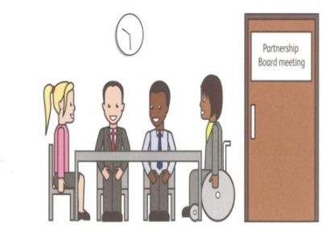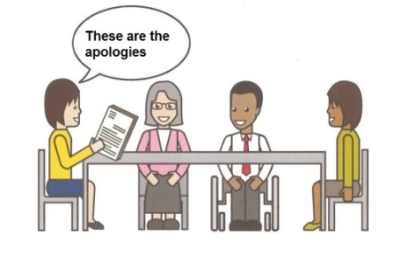 | Welcome and introductions  Apologies – People who can’t come to the meeting | Anne White  Karen Haltham
2. | 6.05-6.10pm  5 minutes |  | Rules of the meeting | Anne White
3. | 6.10–6.25 pm  15 minutes |  | Minutes of the previous meeting of the Disability Partnership Board:  3.1. Any amendments?  3.2. Matters Arising – Action Log | All
4. | 6.25-6.30 pm  5 minutes |  | Board Members Updates including:  - Thurrock Coalition  4.2 Mental Health Forum  4.3 Autism Action Group | All
5. |  |  | Thurrock Council Update  See Agenda item 8 Local Account | Les Billingham
6. | 6.30-6.35 pm  5 minutes |  | Safeguarding Update | Graham Carey
7. | 6.35-6.45 pm  10 minutes |  | Refreshment Break | All
8. | 6.45–7.10 pm  25 minutes |  | Local Account Presentation | Les Billingham
9. | 7.10-7.55 pm  45 minutes |  | Open Discussion on the Local Account Presentation | Les Billingham/All
10. | 7.55-8.00  5 minutes |  | Any Other Business | All
 | 8:00pm - Finish | 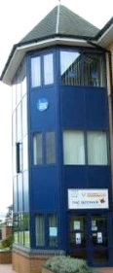 | Date and Time of next meeting:  Thursday 14th December 2017  Arrive from 5.30pm for 6pm – 8pm  The Beehive, West Street  Future Agenda Items: | All

