Thurrock Disability Partnership Board
Thursday 14th December 2017- 5.30pm Arrival for 6pm -8pm meeting
The Beehive
Agenda
Item | Timings | Pictures | Item | Led by
 | 5:30–6:00pm |  | Arrival & Networking
1. | 6:00-6:05pm  5 minutes | 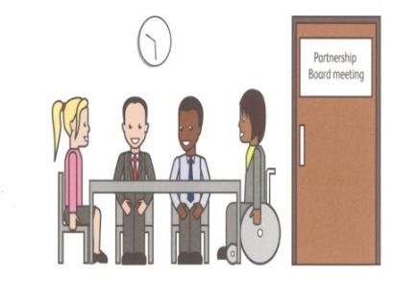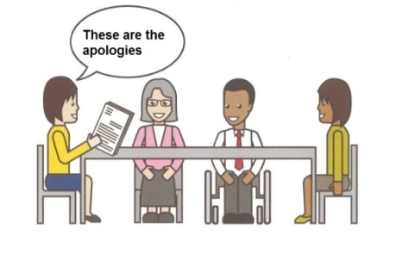 | Welcome and introductions  Apologies – People who can’t come to the meeting | Anne White  Karen Haltham
2. | 6.05-6.10pm  5 minutes |  | Rules of the meeting | Anne White
3. | 6.10–6.25 pm  15 minutes |  | Minutes of the previous meeting of the Disability Partnership Board:  3.1. Any amendments?  3.2. Matters Arising – Action Log | All
4. | 6.25–6.35 pm  10 minutes |  | Market Position Statement Presentation | Sarah Turner
5. | 6:35-7.10 pm  35 minutes |  | Breakout Groups Market Position Statement – Easy Read Consultation Document | All
6. | 7.10-7.20 pm  10 minutes |  | Refreshment Break | All
7. | 7.20-7.35 pm  15 minutes |  | Board Members Updates including:  4.1 Thurrock Council  4.2 Thurrock Coalition | Les Billingham  Ian Evans
8. | 7.35-7.40 pm  5 minutes |  | Safeguarding Update | Graham Carey
9. | 7.40-8.00  20 minutes |  | Board Members Suggestions for future meeting topics &  Any Other Business | All
10 | 8:00pm - Finish | 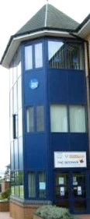 | Date and Time of next meeting:  Thursday 15th March 2018  Arrive from 5.30pm for 6pm – 8pm  The Beehive, West Street | All

