Thurrock Disability Partnership Board
Thursday 16th March 2017- 5.30pm Arrival for 6pm -8pm meeting
The Beehive
Agenda
Item | Timings | Pictures | Item | Led by
 | 5:30–6:00pm |  | Arrival & Networking
1. | 6:00-6:05pm  5 minutes | 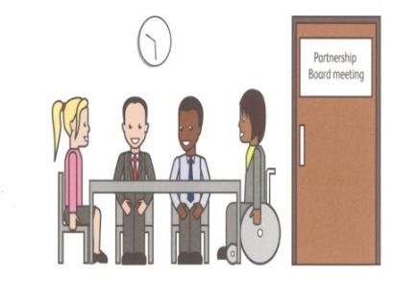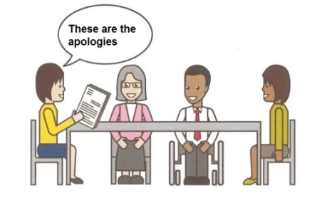 | Welcome and introductions  Apologies – People who can’t come to the meeting | Anne White  Ian Evans
2. | 6.05-6.10pm  5 minutes |  | Rules of the meeting | Anne White
3. | 6.10 – 6.25pm  15 minutes |  | TransVol Presentation – Service Update | John Paddick
4 | 6.25-6.30pm  5 minutes | Health & Well-Being | Update on the Health and Wellbeing Strategy feedback so far and brief  introduction to the Theme of the meeting: The Thurrock Health and Wellbeing Strategy Goal E – Healthier for Longer | Darren Kristiansen
5. | 6.30-6.55pm  25 minutes |  | Discussion and Breakout Groups-Thurrock Health and Wellbeing Strategy Goal E | All
6. | 6.55-7.05pm  10 minutes |  | Breakout Group Feedback from the Discussion of the Thurrock Health & Wellbeing Strategy – Goal E | All
7. | 7.05-7.10pm  5 minutes |  | Tea/coffee | All
8. | 7.10-7.25  15 minutes |  | Minutes of the previous meeting of the Disability Partnership Board:  8.1. Any amendments?  8.2. Matters Arising | All
9. | 7.25-7.35pm  10 minutes |  | Board Members Updates including:  - Thurrock Coalition  - Mental Health Forum  - Autism Action Group | All
10. | 7:35-7:45pm  10 minutes |  | Thurrock Council Update: | Les Billingham
11. | 7.45-7.55pm  5 minutes |  | Safeguarding Update | Graham Carey
12. | 7.55- 8pm  5 minutes |  | Any Other Business
 | 8:00pm - Finish | 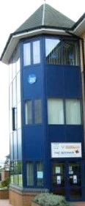 | Date and Time of next meeting:  Thursday 15th June 2017  Arrive from 5.30pm for 6pm – 8pm  The Beehive, West Street  Future Agenda Items:  Encourage new Membership from people who use services | All

