Thurrock Disability Partnership Board
Thursday 15th June 2017- 5.30pm Arrival for 6pm -8pm meeting
The Beehive
Agenda
Item | Timings | Pictures | Item | Led by
 | 5:30–6:00pm |  | Arrival & Networking
1. | 6:00-6:05pm  5 minutes | 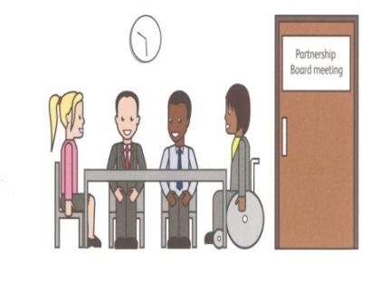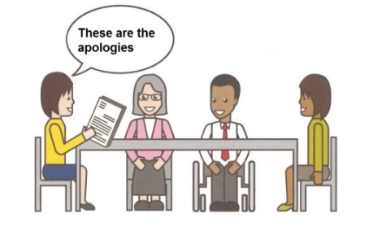 | Welcome and introductions  Apologies – People who can’t come to the meeting | Anne White  Ian Evans
2. | 6.05-6.10pm  5 minutes |  | Rules of the meeting | Anne White
3. | 6.10–6.25 pm  15 minutes |  | Minutes of the previous meeting of the Disability Partnership Board:  3.1. Any amendments?  3.2. Matters Arising | All
4. | 6.25-6.35 pm  10 minutes |  | Board Members Updates including:  - Thurrock Coalition  4.2 Mental Health Forum  4.3 Autism Action Group | All
5. | 6.35- 6.45 pm  10 minutes |  | Thurrock Council Update | Les Billingham
6. | 6.45-6.50 pm  5 minutes |  | Safeguarding Update | Graham Carey
7. | 6.50-7.00 pm  10minutes |  | Refreshment Break | All
8. | 7.00–7.15 pm  15 minutes |  | Ategi Shared Lives Scheme Introduction and Presentation | Chloe Newton  (Shared Lives Scheme Manager)
9. | 7.15-7.25 pm  10 Minutes |  | Ategi – Questions and Answers | Chloe Newton  (Shared Lives Scheme Manager)
10. | 7.25-7.40 pm  15 Minutes |  | SOUTHEND, ESSEX & THURROCK (SET)  TRANSFORMING CARE PARTNERSHIP  Improving care in Essex for People with a learning disability and/or autism | Catherine Wilson
11. | 7.40-7.50 pm  10 Minutes |  | Transforming Care Partnership  Questions and Answers | Catherine Wilson
12. | 7.50- 8pm  10 minutes |  | Any Other Business | All
 | 8:00pm - Finish |  | Date and Time of next meeting:  Thursday 21st September 2017  Arrive from 5.30pm for 6pm – 8pm  The Beehive, West Street  Future Agenda Items:  Thurrock Local Account | All

